

Online Lab Management System

# (First Review Report)

# Submitted By:-

# Shivam Sethi(17BCE2010)

# Darsh Sheth(17BCB0014)

# Submitted to:-

# Dr. Ramanathan L

**Abstract:-**

As the name suggests, the lab management system is an application that helps in maintaining the smooth running of the operations in a lab. In computer labs, you can find different computers that are kept to perform various tasks as per the user’s desire. All the information related to this stuff can be stored in the laboratory management system with great ease. This will be one of the projects that will be very useful and will help to maintain the activities of the laboratory really well.

The features that can be included in the online lab management system are as follows:

• Administrator database management: Details related to the administrators. These people have access to all information stored in the lab. They control the users and have the power to give them permissions and revoke them when needed.

• User database management: The details related to users like name, age, the project conducted and so on can be maintained in the database.

The online lab management system will be one of the projects that will help in improving the activities that take place in the laboratory. There will be many computers that will be present in the laboratory. Through this application, the users or the admins can control the lab. Even the records of the particular user must be kept in the right place.

**Introduction:-**

The main objective of the Project is to manage the details of Student, Lab, Report, Update and View. It manages All the information about the student, Lab. Report, Teacher. The project is built both at administrative as well as user end. But the admin (Teacher) will have more privileged access as compared to Student’s End. The purpose of this project is to built an application program that reduces the manual work for managing the Student Data, Course Materials, Lab Data, etc.

**Some Features of The System are:-**

* Online lab management is easy as it connects all systems to a common server which can be manipulated only by the administrator.
* Userid and password are provided to students and admins which is unique due to which its data will be secured.
* Student problems can be reported by filing queries.
* Students can upload their assignments and get marks.
* Data of a particular student is secured and nobody can access it except the student.

These functionality are going to be implemented sequentially. MongoDB JSON Collections will be first implemented to store the Values needed for Modules(Like Admin and Student)

Then the databases are going to be implemented using pymongo as connector working between MongoDB and Backend where using Flask Web framework we are going to implement backend.

Front end will be implemented using HTML and CSS.

**Project Resource Requirements:-**

**Software Requirements:-**

(i)Web Frameworks:-Flask

(ii)Language Requirements for Implementation:-Python

(iii)Database Requirements:- MongoDB

**Hardware Requirements:-**

A Working Computer with minimum 8GB of RAM, Compatible Operating System (e.g-Windows) with all the required softwares and a sufficient processor(i5-7700HQ) for handling all the Computations.

Hard Disk:-10 GB

**ER Diagram:-**

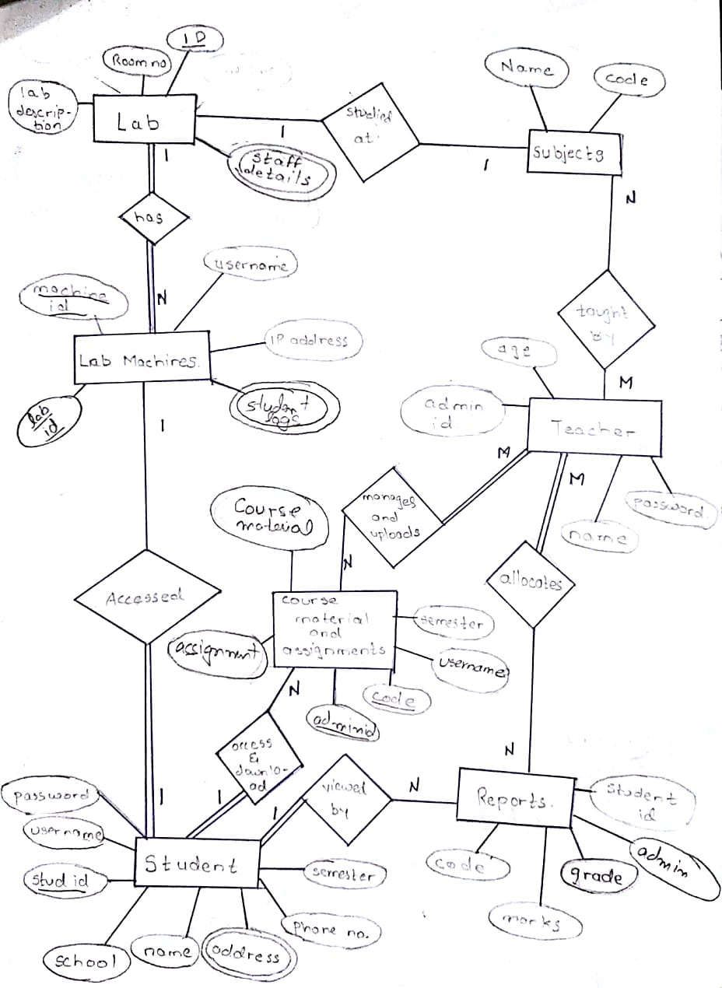

3 more tables for m:n cardinality ration relationship are needed they are not present.Make them while making project

**ER to Relational Diagram:-**

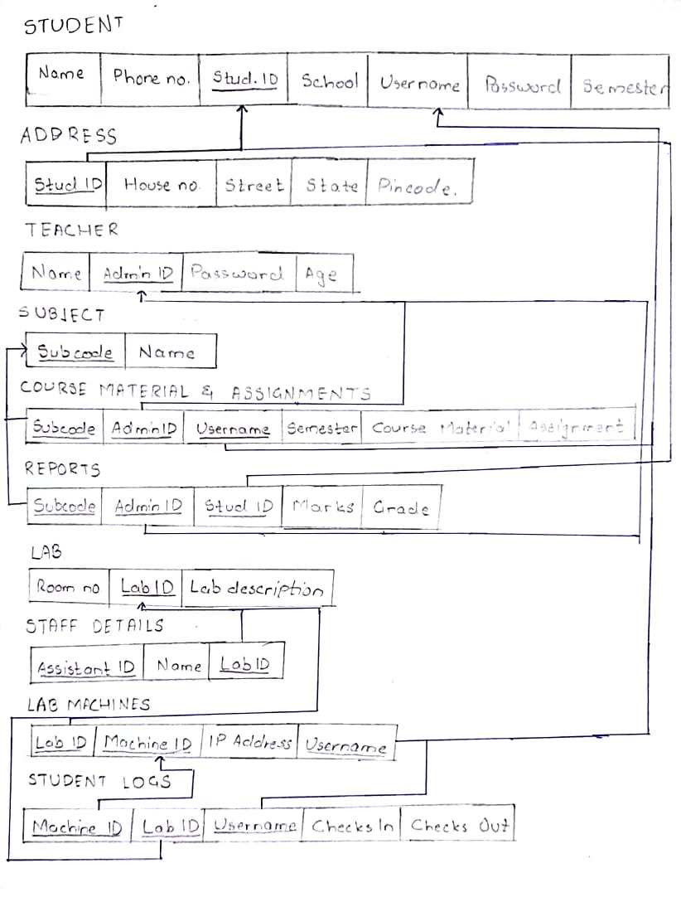

**Table and Constraints:-**

**Student :-**

|  |  |  |
| --- | --- | --- |
| **Attributes** | **Datatype** | **Constraint** |
| Student ID | Varchar | Primary Key |
| Username | Varchar | Unique constraint |
| Name | Varchar | Not null |
| School | Varchar | Not null |
| Password | Varchar | Unique Constraint |
| Phone number | Number | Not null |
| Semester | Varchar | Not null |

**Address:-**

|  |  |  |
| --- | --- | --- |
| **Attributes** | **Datatype** | **Constraint** |
| House No. | Varchar | Not null |
| Street | Varchar | Not null |
| State | Varchar | Not null |
| Pincode | Number | Not null |
| Student ID | Varchar | Primary key and Foreign Key (referenced from Student table on delete cascade) |

**Student ID = Primary Key**

**Lab Machines:-**

|  |  |  |
| --- | --- | --- |
| **Attributes** | **Datatype** | **Constraint** |
| Lab ID | Varchar | Foreign Key referenced from Lab table on delete set null |
| Machine ID | Varchar | Not null and unique constraint |
| IP Address | Varchar | Not null and unique constraint |
| Username | Varchar | Foreign key referenced from Student Table on delete set null |

**(Machine ID, Lab Id, Username) = Primary Key**

**Course material and assignments:-**

|  |  |  |
| --- | --- | --- |
| **Attributes** | **Datatype** | **Constraint** |
| Subcode | Varchar | Foreign Key referenced from Subject Table |
| Adminid | Varchar | Foreign Key referenced from Teacher Table |
| username | Varchar | Foreign Key referenced From |
| Semester | Varchar | Not null |
| Course Material | RAW |  |
| Assignment | RAW |  |

**(Subcode, Username,adminid) = Primary Key**

**Teacher:-**

|  |  |  |
| --- | --- | --- |
| **Attributes** | **Datatype** | **Constraint** |
| Admin Id | Varchar | Primary Key |
| Name | Varchar | Not null |
| Password | Varchar | Not null and unique |
| Age | Number | Not null |

**Reports:-**

|  |  |  |
| --- | --- | --- |
| **Attributes** | **Datatype** | **Constraints** |
| Subcode | Varchar | Foreign Key referenced from Subject Table on delete set default |
| Adminid | Varchar | Foreign Key referenced from Subject Table on delete set default |
| Student ID | Varchar | Foreign Key referenced from Subject Table on delete cascade |
| Marks | Number |  |
| Grade | Char |  |

Primary Key = (Subcode,Adminid,Student ID)

**Lab:-**

|  |  |  |
| --- | --- | --- |
| **Attributes** | **Datatype** | **Constraints** |
| Lab ID | Varchar | Primary Key |
| Room No | Varchar | Not null |
| Lab description | Varchar | Not null |

**Staff Details:-**

|  |  |  |
| --- | --- | --- |
| **Attributes** | **Datatype** | **Constraints** |
| Assistant ID | Varchar | Not null and unique constraint |
| Name | Varchar | Not null |
| Lab ID | Varchar | Foreign Key referenced from Lab machine table on delete cascade |

**(Lab ID, Assistant ID):- Primary Key**

**Student Logs:-**

|  |  |  |
| --- | --- | --- |
| **Attributes** | **Datatype** | **Constraints** |
| Machine ID | Varchar | Foreign Key referenced from Lab machine table on delete set null |
| Lab ID | Varchar | Foreign Key referenced from Lab machine table on delete cascade |
| Username | Varchar | Foreign Key referenced from Student table set on delete cascade |
| Checks in | Varchar |  |
| Checks out | Varchar |  |

**(Machine ID,Lab ID,Username):- Primary Key**

**Work Breakdown structure template:-**

|  |  |  |
| --- | --- | --- |
| **Team Member Registration Number** | **Name** | **Work Assigned** |
| 17BCE2010 | Shivam Sethi | (i)Developing Web Framework using Flask  (ii)Using Python implementing Backend by using Pymongo as API to MongoDB  (iii) Storing JSON File structures and collections in MongoDB Database |
| 17BCB0014 | Darsh Sheth | (i)Developing Frontend using HTML and CSS |

**Literature Survey:-**

In This Section, the our main focus is to survey the already present research papers and trying to approach the same problem through a refined and improvised method, therefore these previous works are very much needed to thoroughly analyse and improve our work.

|  |  |  |  |  |
| --- | --- | --- | --- | --- |
| **Authors** | **Title** | **Purpose** | **Advantages** | **Disadvantages** |
| **[1]Ms. Rashmi Janbandhu, Ms. Bhagyashree Gaurkhede, Ms. Gayatri Puri, Ms. Neelam Bahekar.** | Computer Lab Monitoring System  *(International Journal on Recent and Innovation Trends in*  *Computing and Communication, Volume : 3 Issue : 3,March 2015)* | Project aim is to monitor the activities of students by the  lecturer and to maintain the control and discipline while  student’s practical performance. | In college computer labs it is used for monitoring the  student activity (client) on their system by lecturer  through server system. They can see their practical performance, login time, can give marks on the basis of  their performance, etc. | Montoring Of Student real time data using Client Server Model Can be hectic and time-consuming |
| **[2]Pratiksha D.Kakde,**  **Minal S.Sutarkar**  **Shubhangi K.Waghmare.** | A Review on Computer Lab Monitoring System  (International Journal of Research In Science & Engineering) | Providing security to all records and databases in every module | Dataflow regarding this project is quite simplified and achievabe | The more focus on security is resulting in functionality being reduced for User(Student) |
| **[3]P.Rajesh Kanna,**  **S.Keerthi** | Automation of Lab with Attendance Monitoring,  Screen Capturing and Performance Analysis | Providing real time data to teacher to monitor student performance in lab | Logout Time recording,  Attendance,  Screen Capturing  Are some of the key features of this project | Blacklisted Applications cannot be stopped automatically and not feasible to implement |
| **[4]Mr.Vipul Shaha,**  **Mr.Amit Arabhavi**  **Mr.Chetan Barage,**  **Mr.Suraj Chavan,**  **Mr.Yogesh Karande,**  **Mr. Bhagyashri Kelkar** | Remote Lab Monitoring. | Implement Client-Server Protocol Implementation to manage by using softwares capable to monitor whole of the network | Monitoring entire lab by sending lab desktop of student machine to teacher machine without knowing to student | File Sharing is not categorised accordingly |
| **[5]V.Ramya,**  **B. Palaniappan,**  **V.Sumathi,** | GSM BASED EMBEDDED SYSTEM FOR REMOTE LABORATORY SAFETY MONITORING AND ALERTING | The aim of this project is to design an embedded system for remote monitoring of the laboratory environment. | Advantage of this automated detection and alarm system is that, it offers faster response time and accurate detection during an emergency.Also it helps us in understanding client chip transfers between a machine and embedded systems | Complex to implement and loosely related to our project part |
| **[6]Wang ping, wany Zheng** | “IEEE, design and Implementation of open computer lab monitoring and management system” IEEE, computer and modernization,2007 | The system created by the authors was one of the first system which was implemented to monitor and manage lab data | Paper implements a different approach as compared to earlier models and is helpful in providing different point of view | Being an early model some techniques becomes obsolete. |
| **[7]**  **YOUwen Zhang, Dong Kang** | Design and Implementation of Computer Room Management System in University | The goal is to improve the quality of college teaching,  improve the level of experiment, while the establishment of a window of information exchange with the outside world. | Paper focuses mainly on ‘time and space’ optimization which will improve the processing speed and reduce space occupied by the data. | The emergence of different querying methods have different SQL query, which leads to programming simple enough, query process is relatively complex, query time is relatively long. Therefore, SQL won’t be able to handle the database properly. |